Get me the IP address of a particular domain (guvi.in)

Ping and host command lists

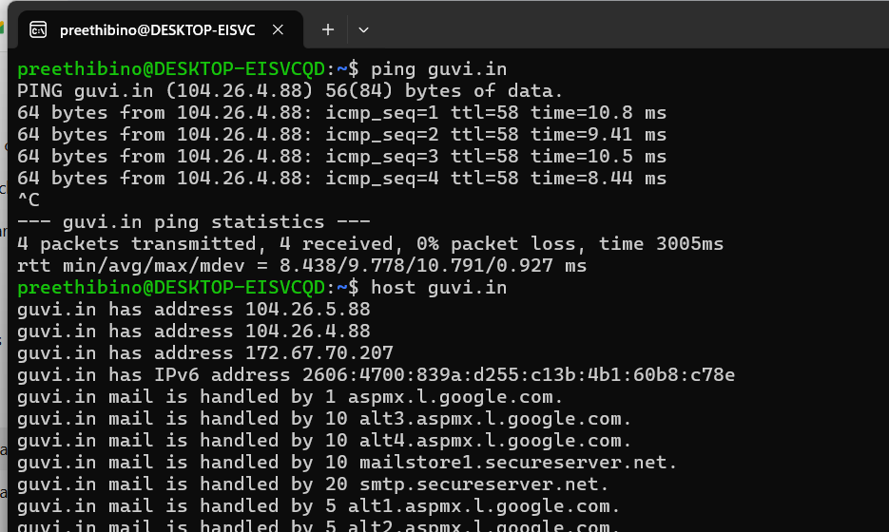

How do I find my CPU/memory usage of my server?

Answer – htop command is used

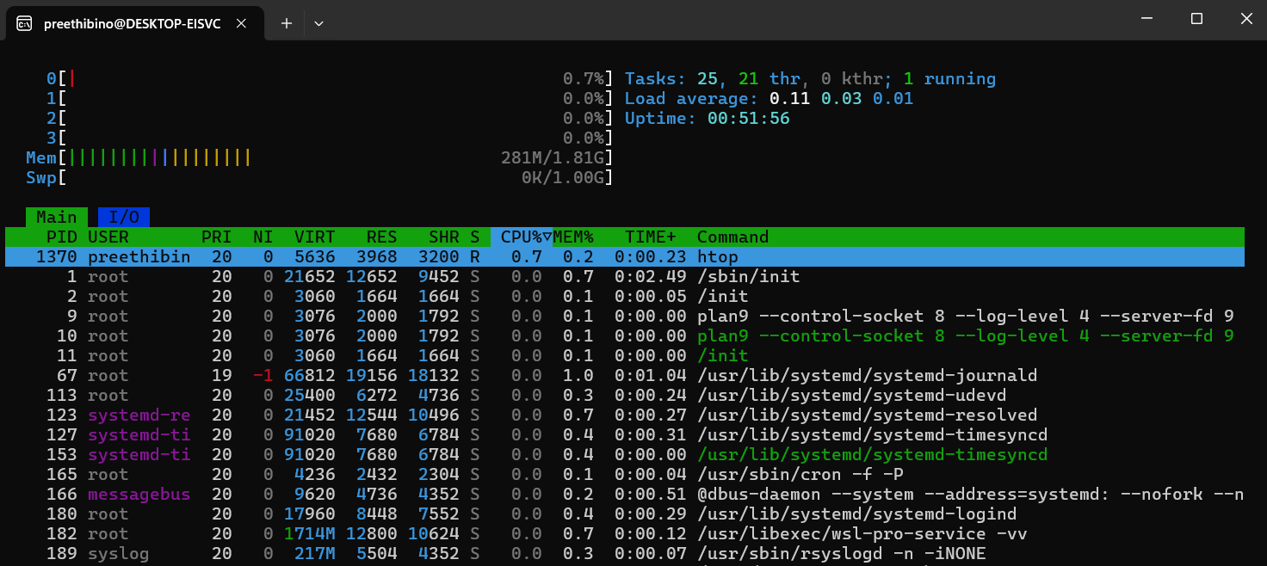

.I have deployed an application in guvi.com:9000, and logs show my app is running, but I’m unable to view the page. Check whether my port is open or not ?

Port is not open as

Netstat -tulpn | grep 9000 gives error

